**System Design**

**Shortener the URL**

Here What we are going to cover

1. Design Requirement and Clarifying the Question

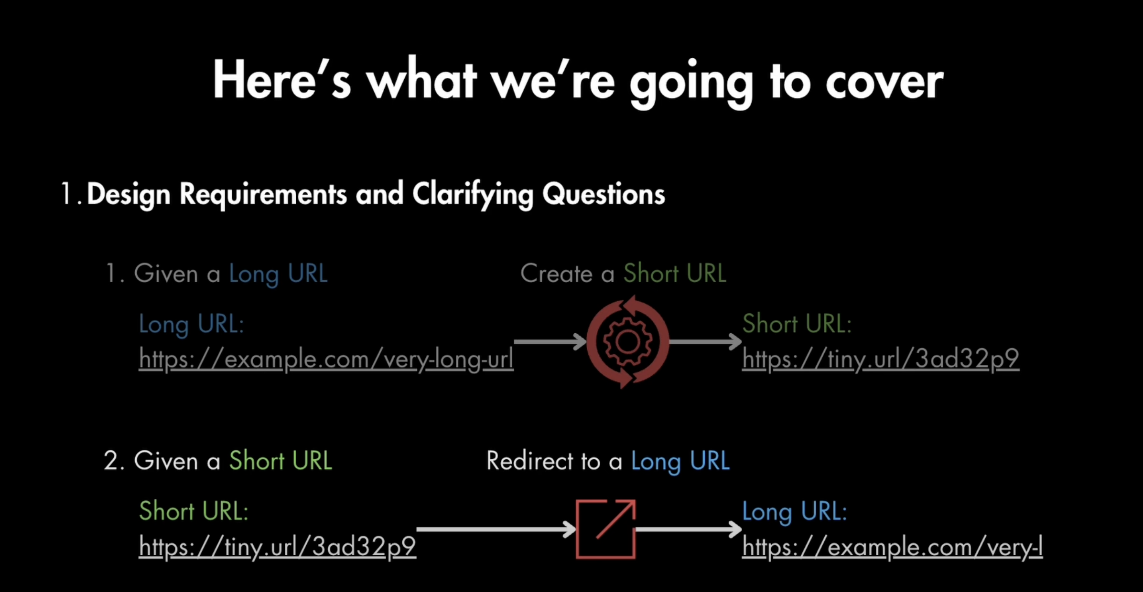

1. High Level System Design

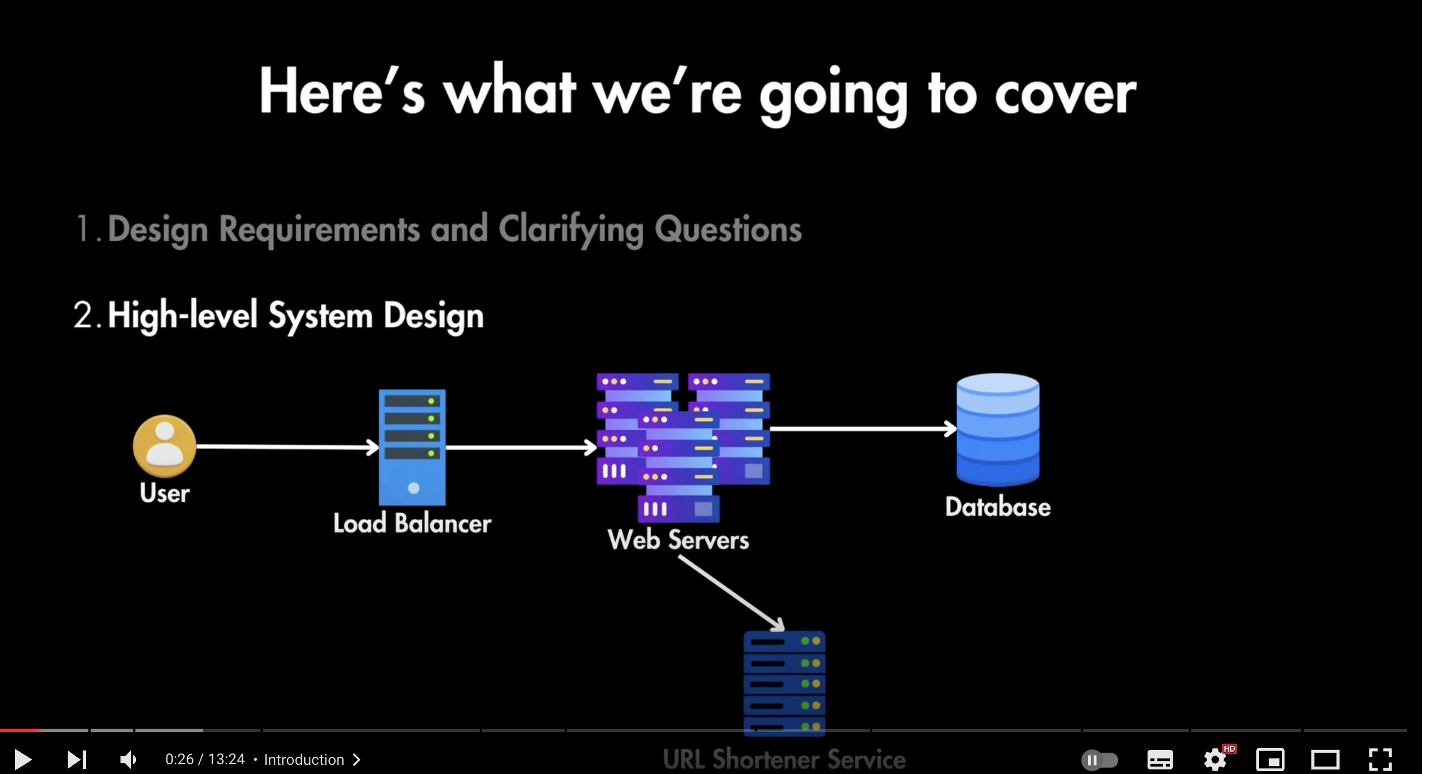

1. Deep Dove into each separate part (API Design, URL Shortener, Database)

API Design

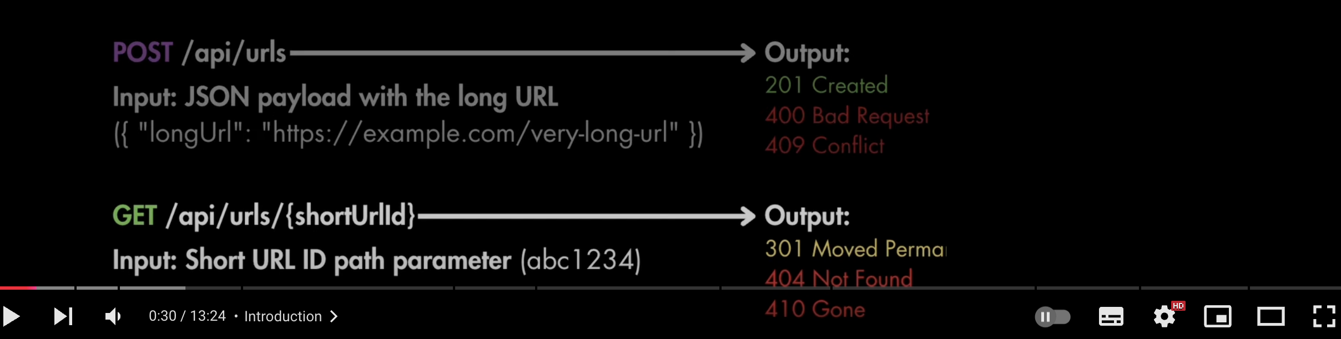

URL Shortener Service

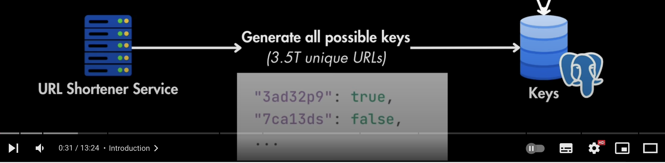

Database

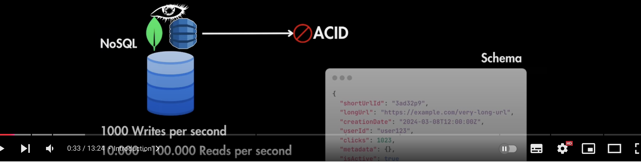

1. Scaling the system for High Availability and low latency

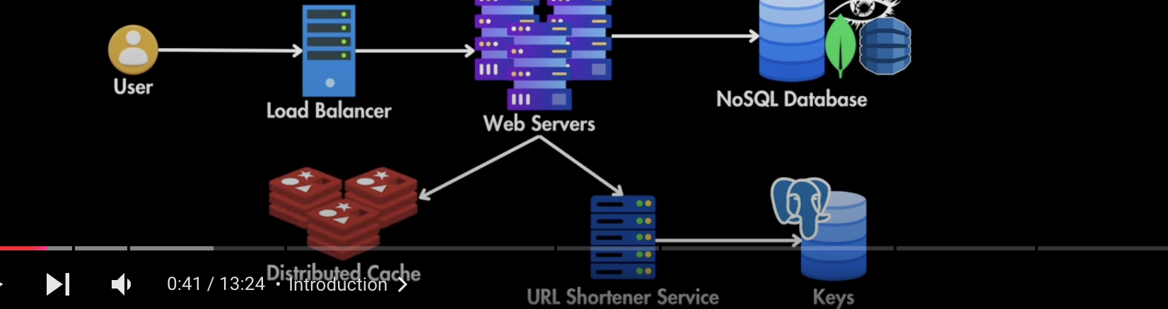

1. Growth and Security Consideration

Functional and Non Functional Requirement

1. Functional Requirement

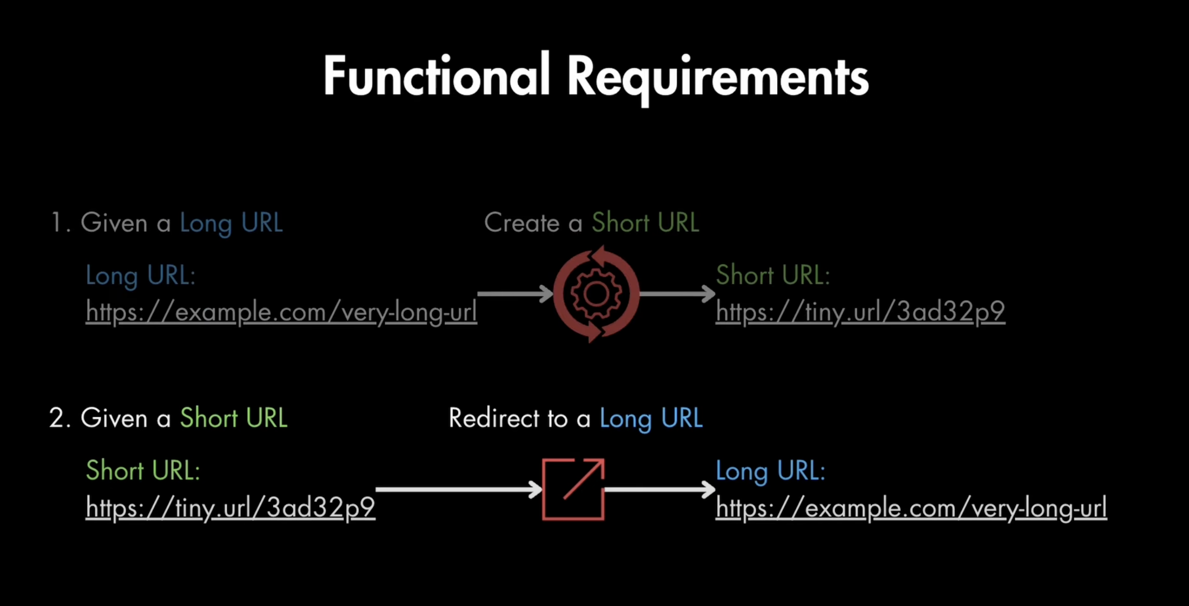

1. Non-Functional Requirement
2. Low Latency
3. High Availability

**Clarifying Question**

These are the question which we can ask from interviewer

1. **How many URLS will be created per second?**

Let us he says 1000 URLs per second

It means we have to write 1000 writes to DB per second.

And every year URLS will be created as

1000*60*60*24*365=31.5B per year Writes

And we are assuming read will be 10 times more than write as 315B Reads

1. **What characters can we use?**

Alphanumeric-A-z, a-z, 0-9=62

1. **What would happen if multiple users have exactly same long URL?**

We should create a new short URL for each user

**Data Estimation**

1. 1000 URLS pers second
2. Alphanumeric
3. Always create new short url for each user

**How Long the URL should be after shortening?**

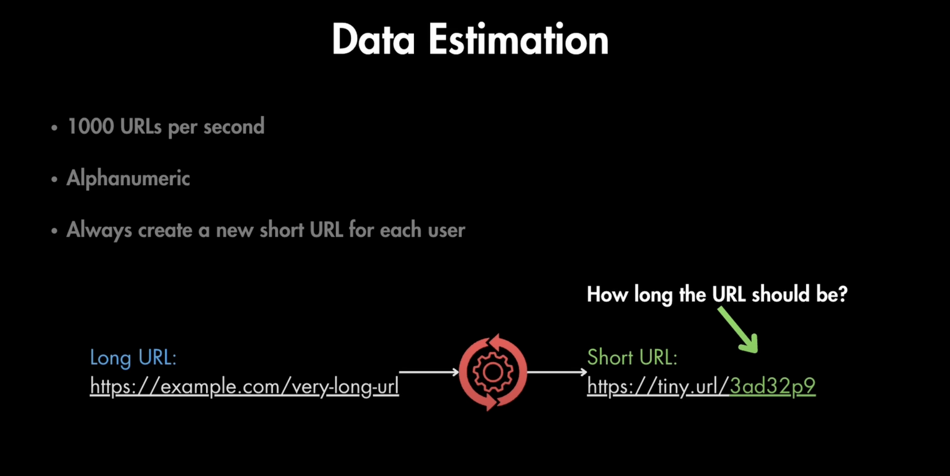

**Let us estimate the unique Number of URLs needed for 10 years**

URLS created in a year= 60*60*24*365*1000=31.5M

Total second in 10 years= 31.5*10=315BM

Total URL in 10 years= 1000*315=315B

With above information we can calculate the length of the URL identifier

If we use 1 character 62^1= 62 unique url

If we use 2 character 62^2= 3844 unique url

If we use 6 character 62^6= 56B unique url

If we use 7 character 62^7= 3.5T unique url

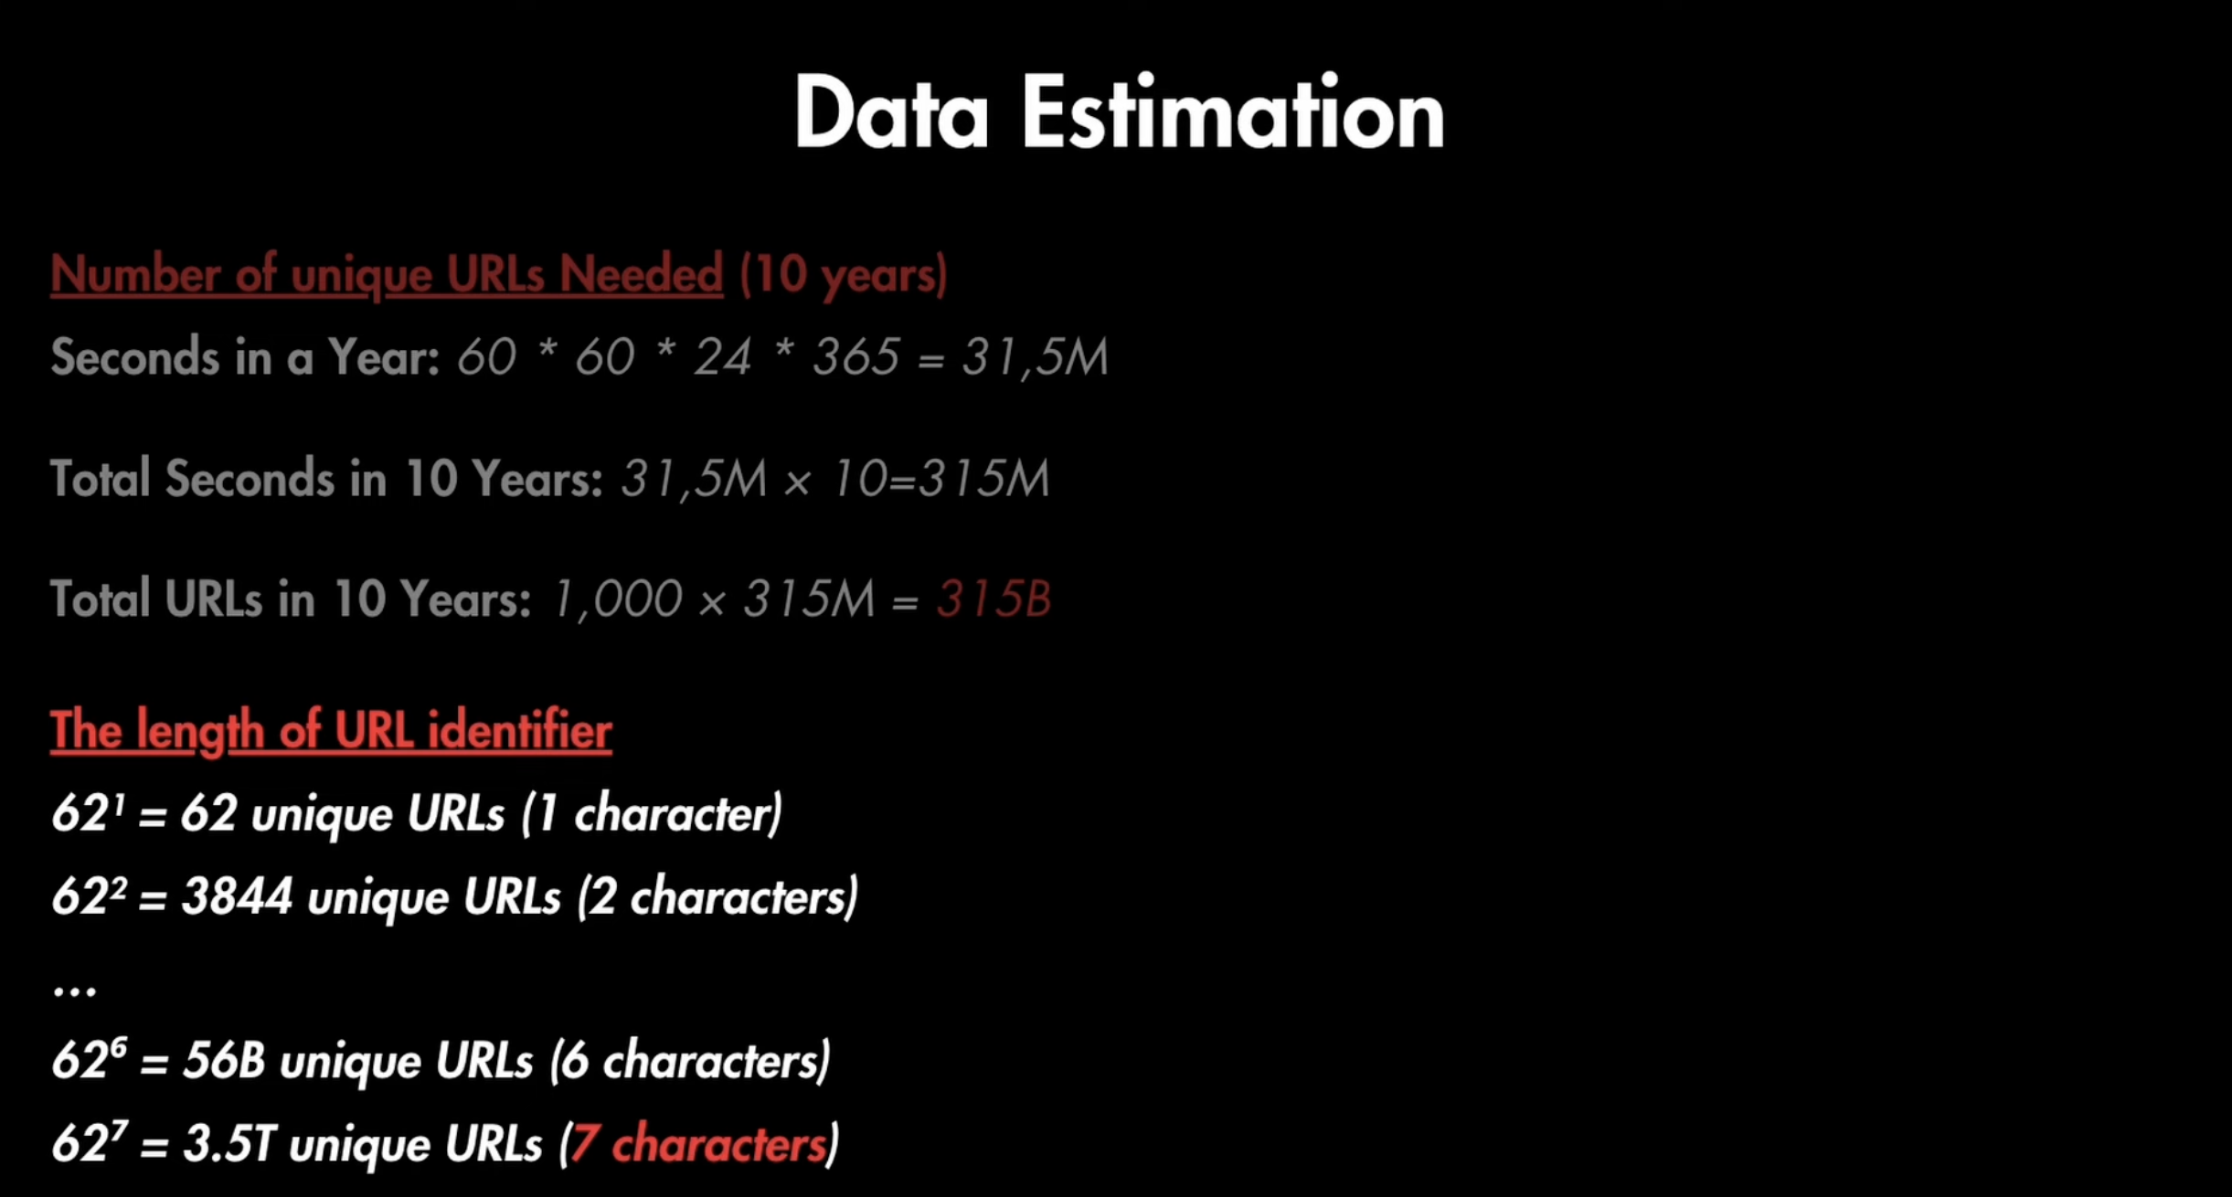

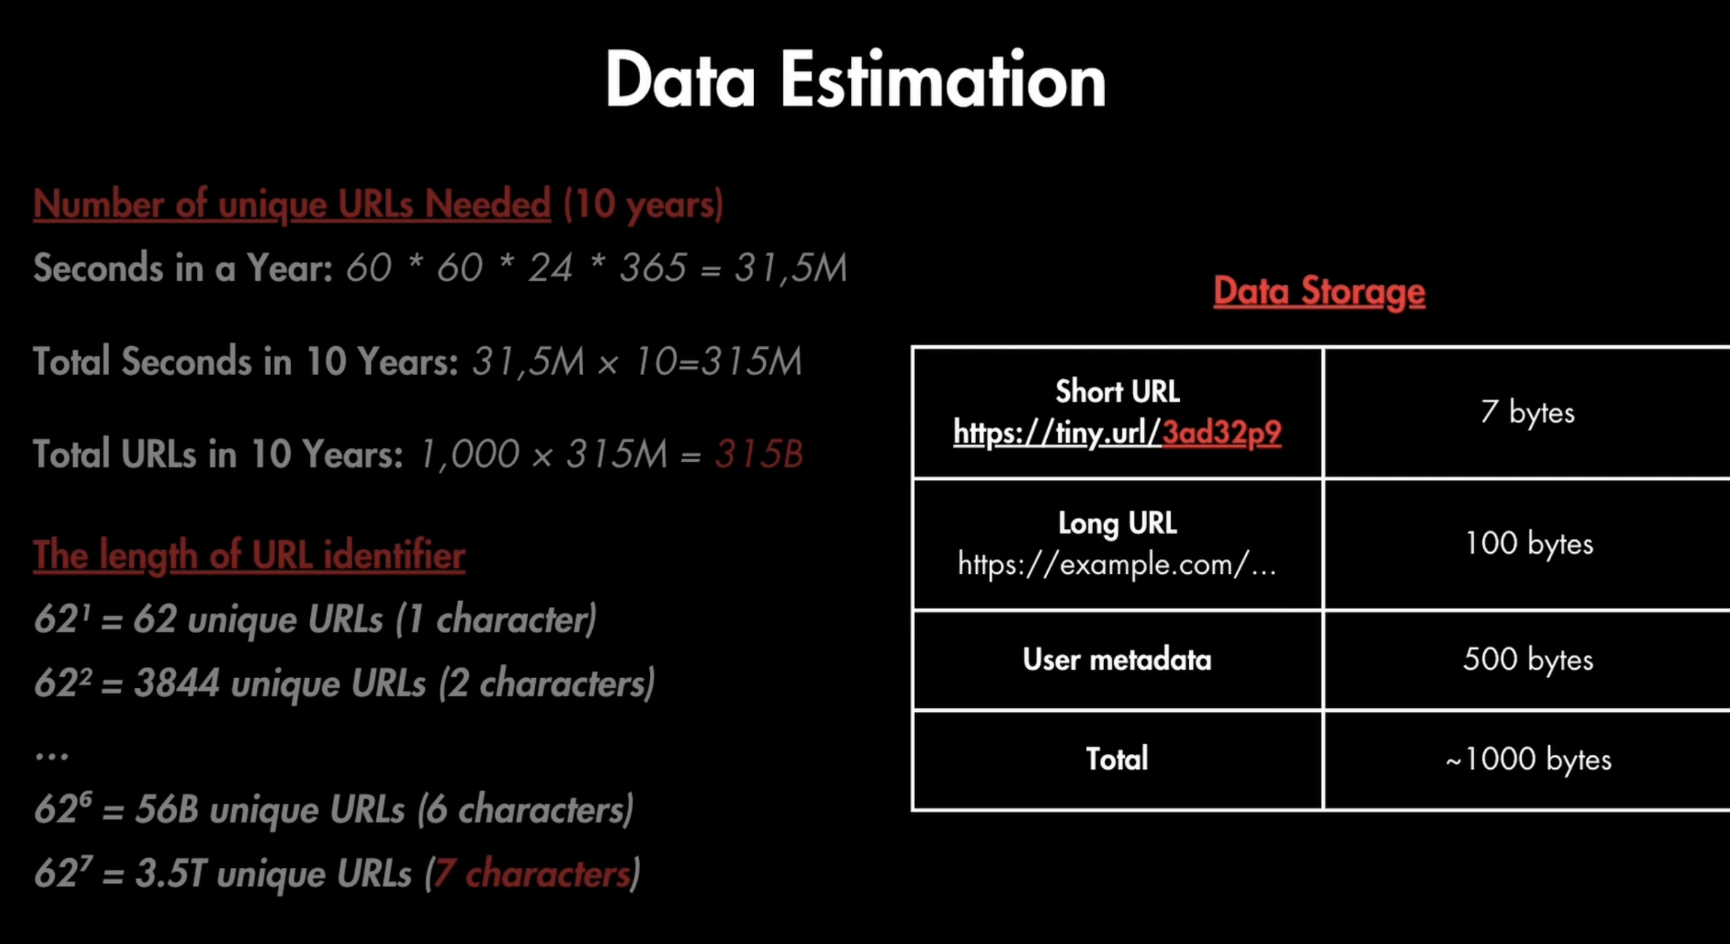

**High Level Design System**

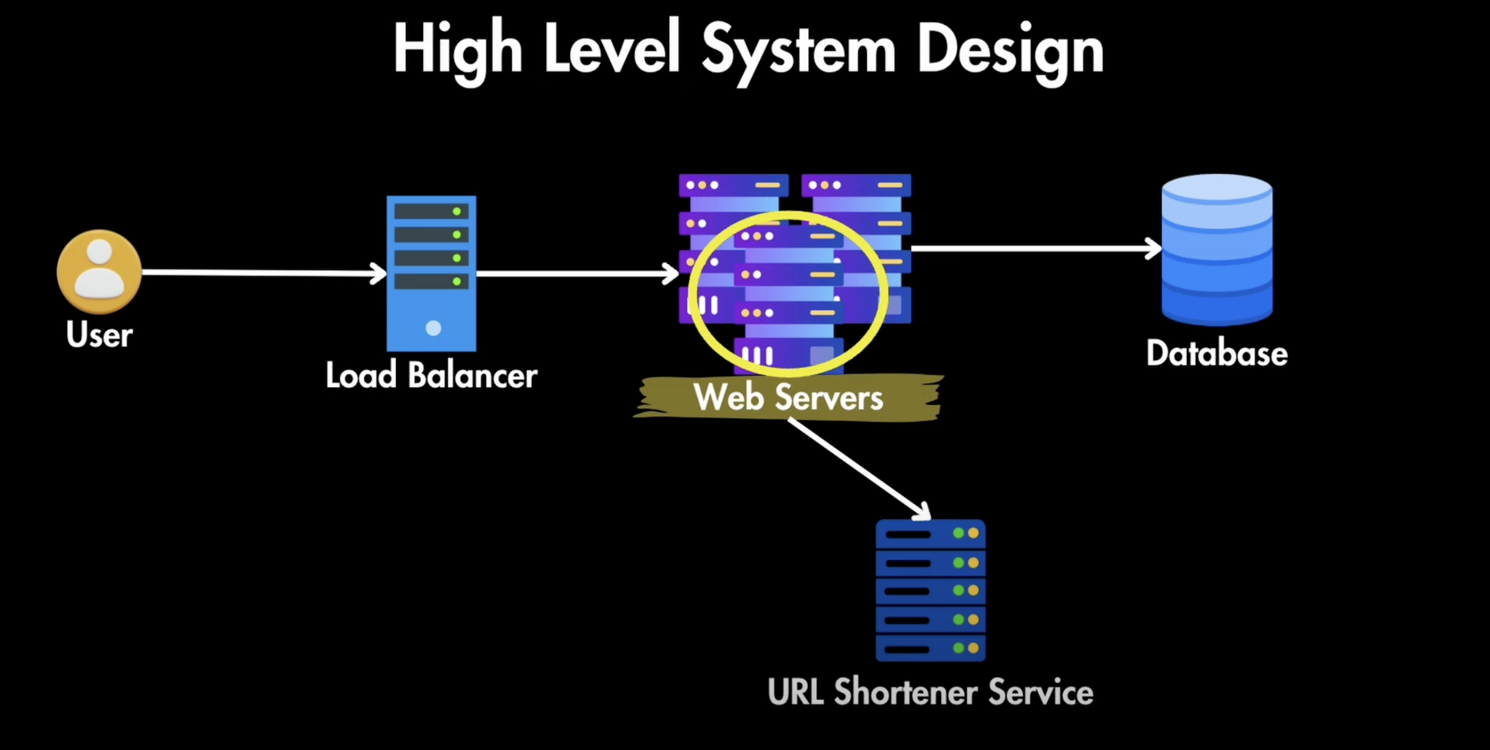

**Load Balancer—**Load Balancer is used to send the equal traffic to the server based upon the hashing concept

**Web Server**—For high availability, there the multiple pods/server are running.

Database🡪 used to store the data of urls

URL Shortener Service🡪 used to short the URL

**API Design**

1. **POST API**

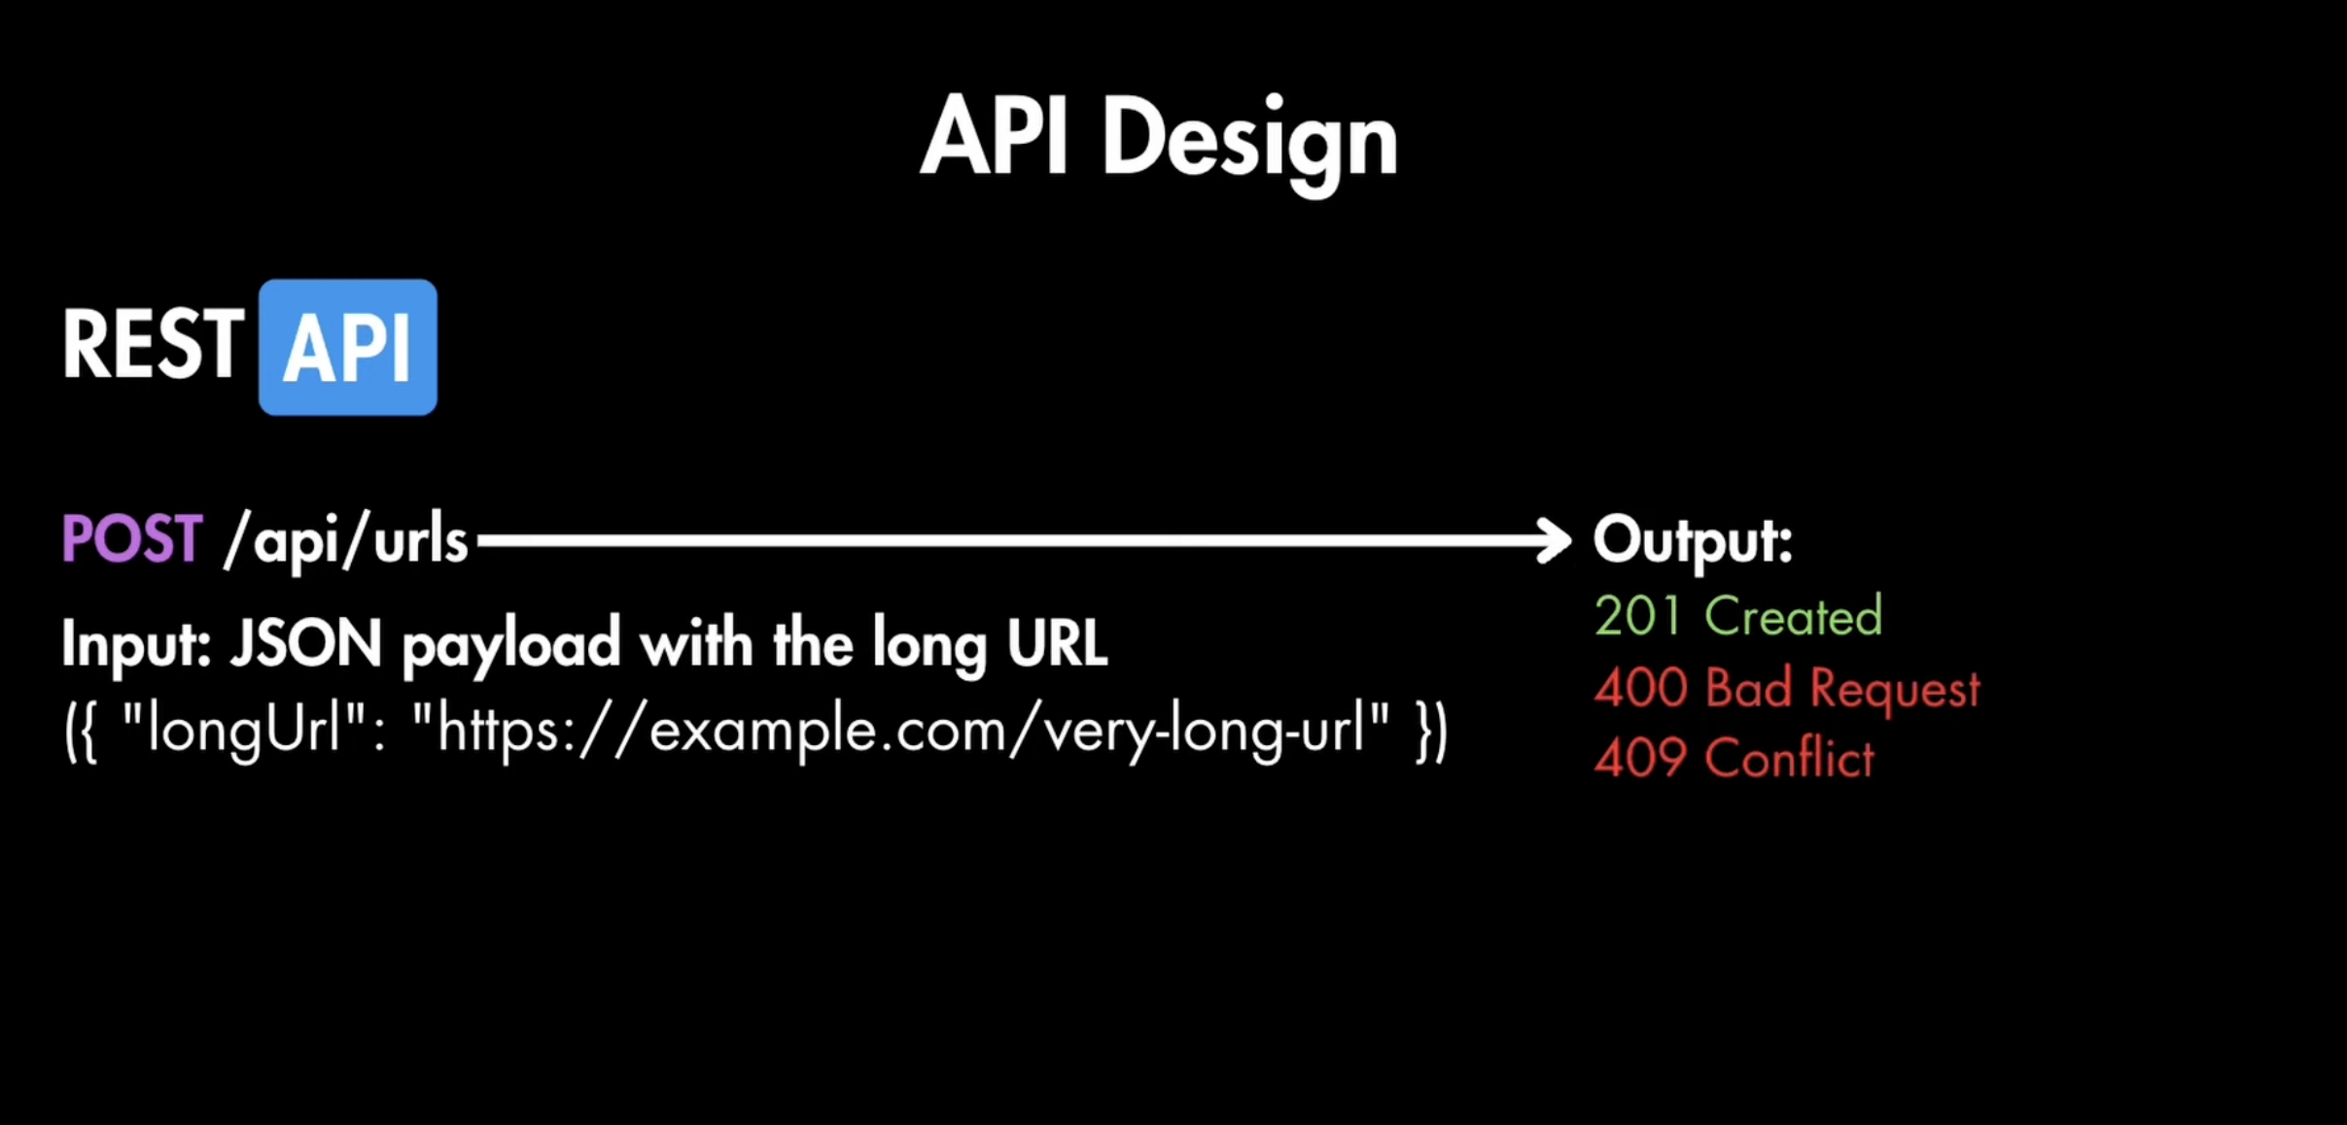

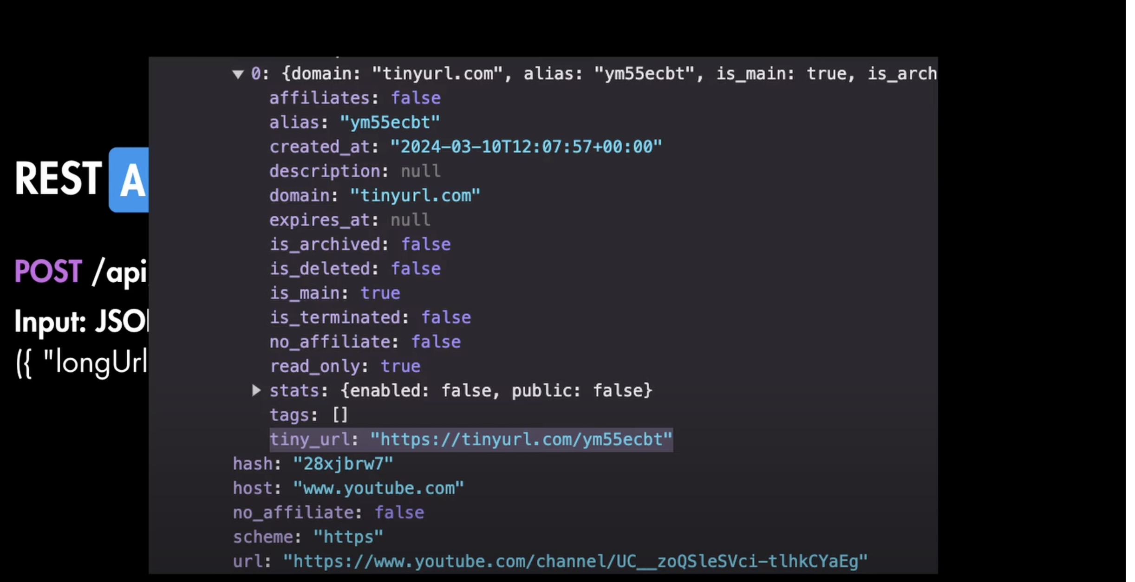

1. **Get API**



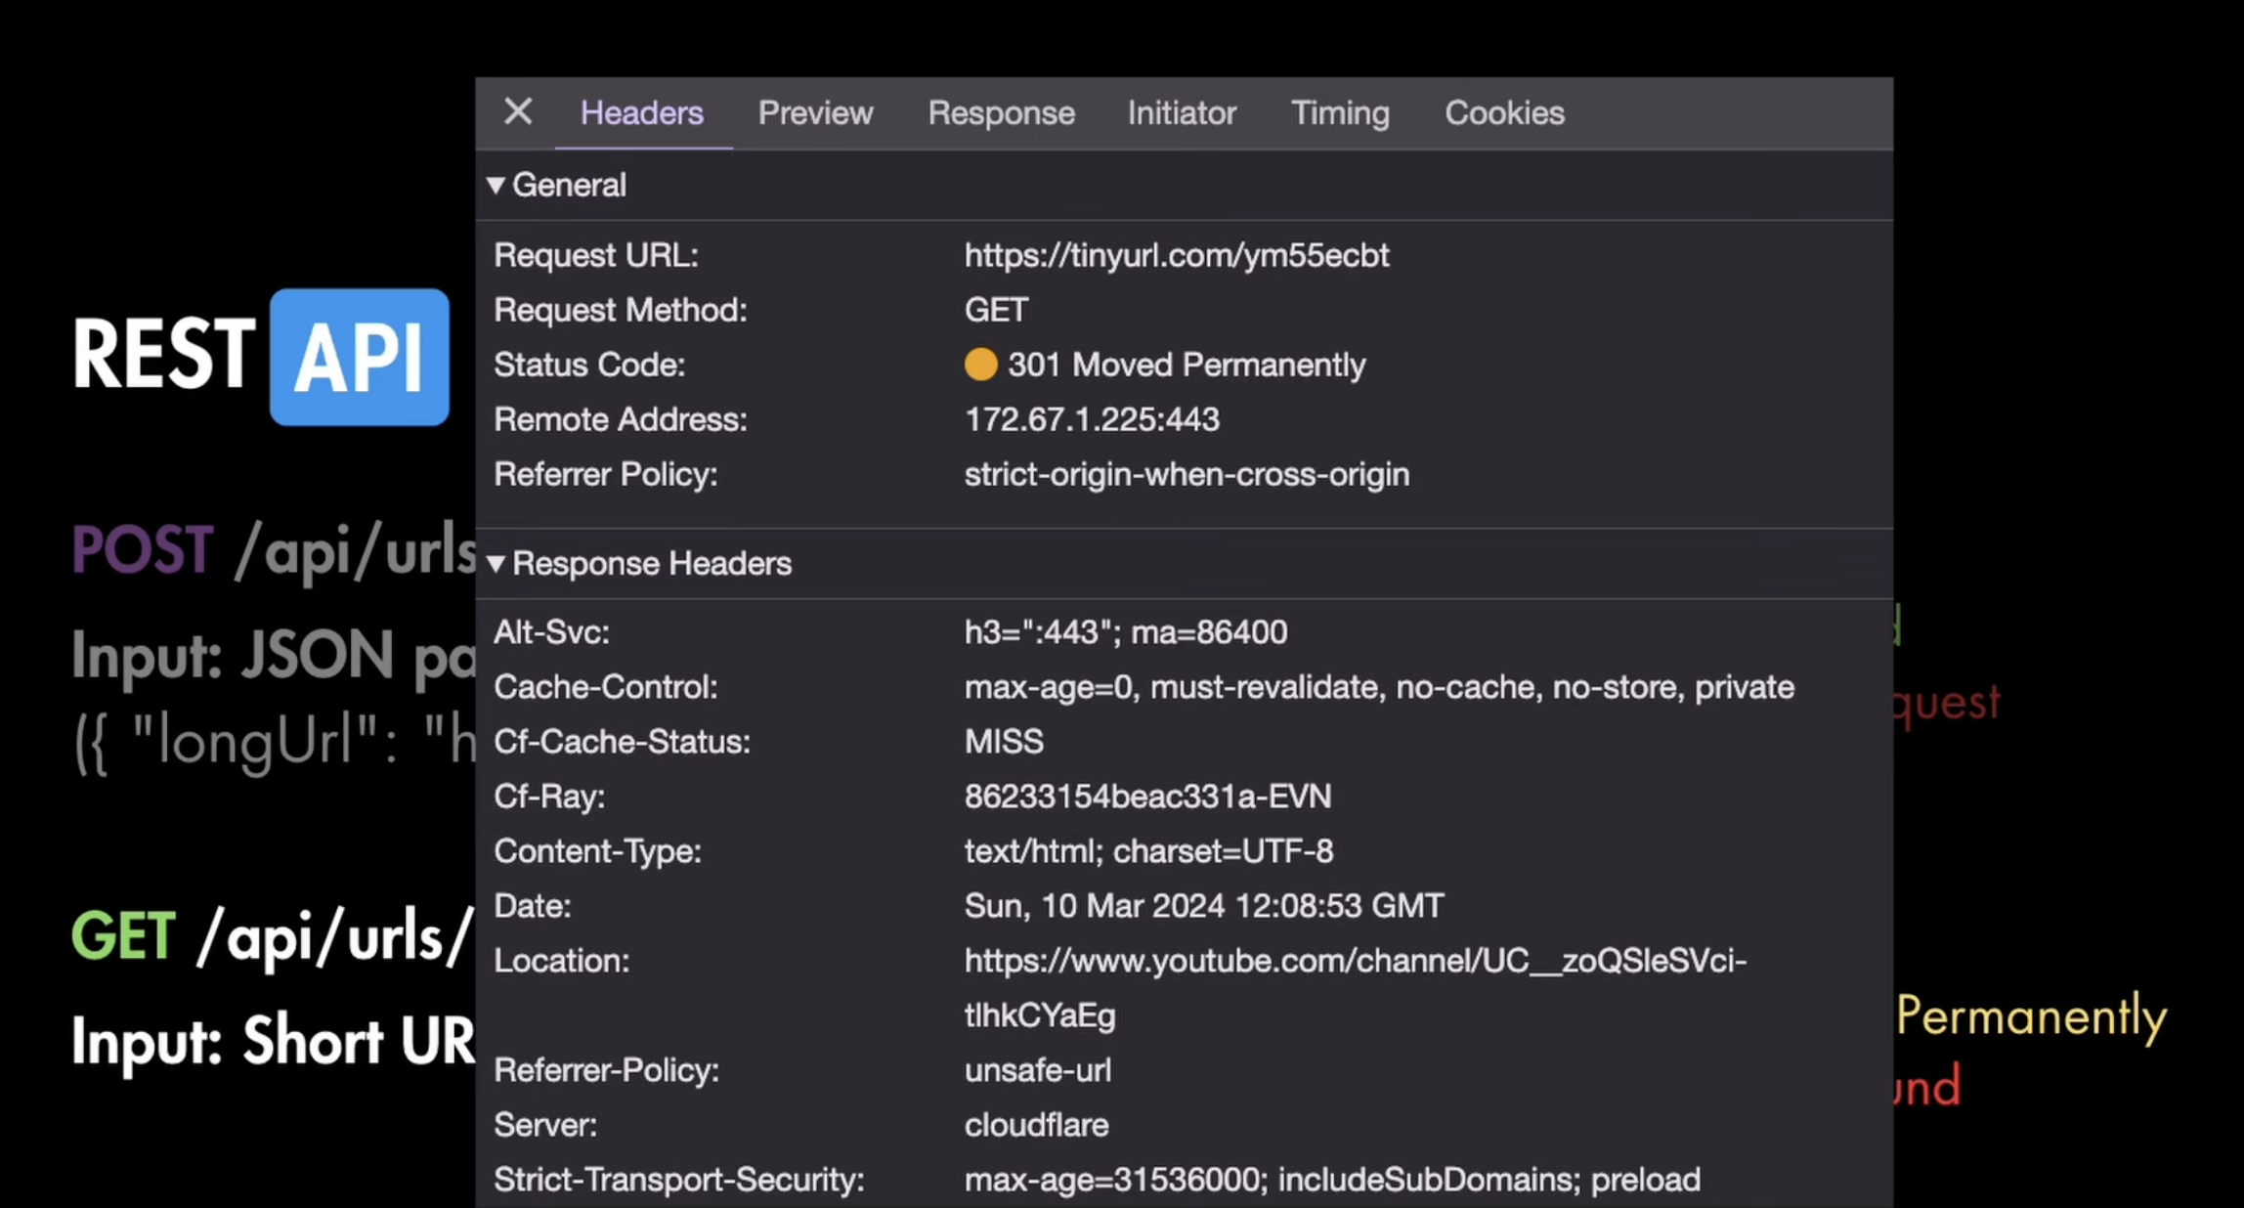

**Database: Storing the Shortening URL**

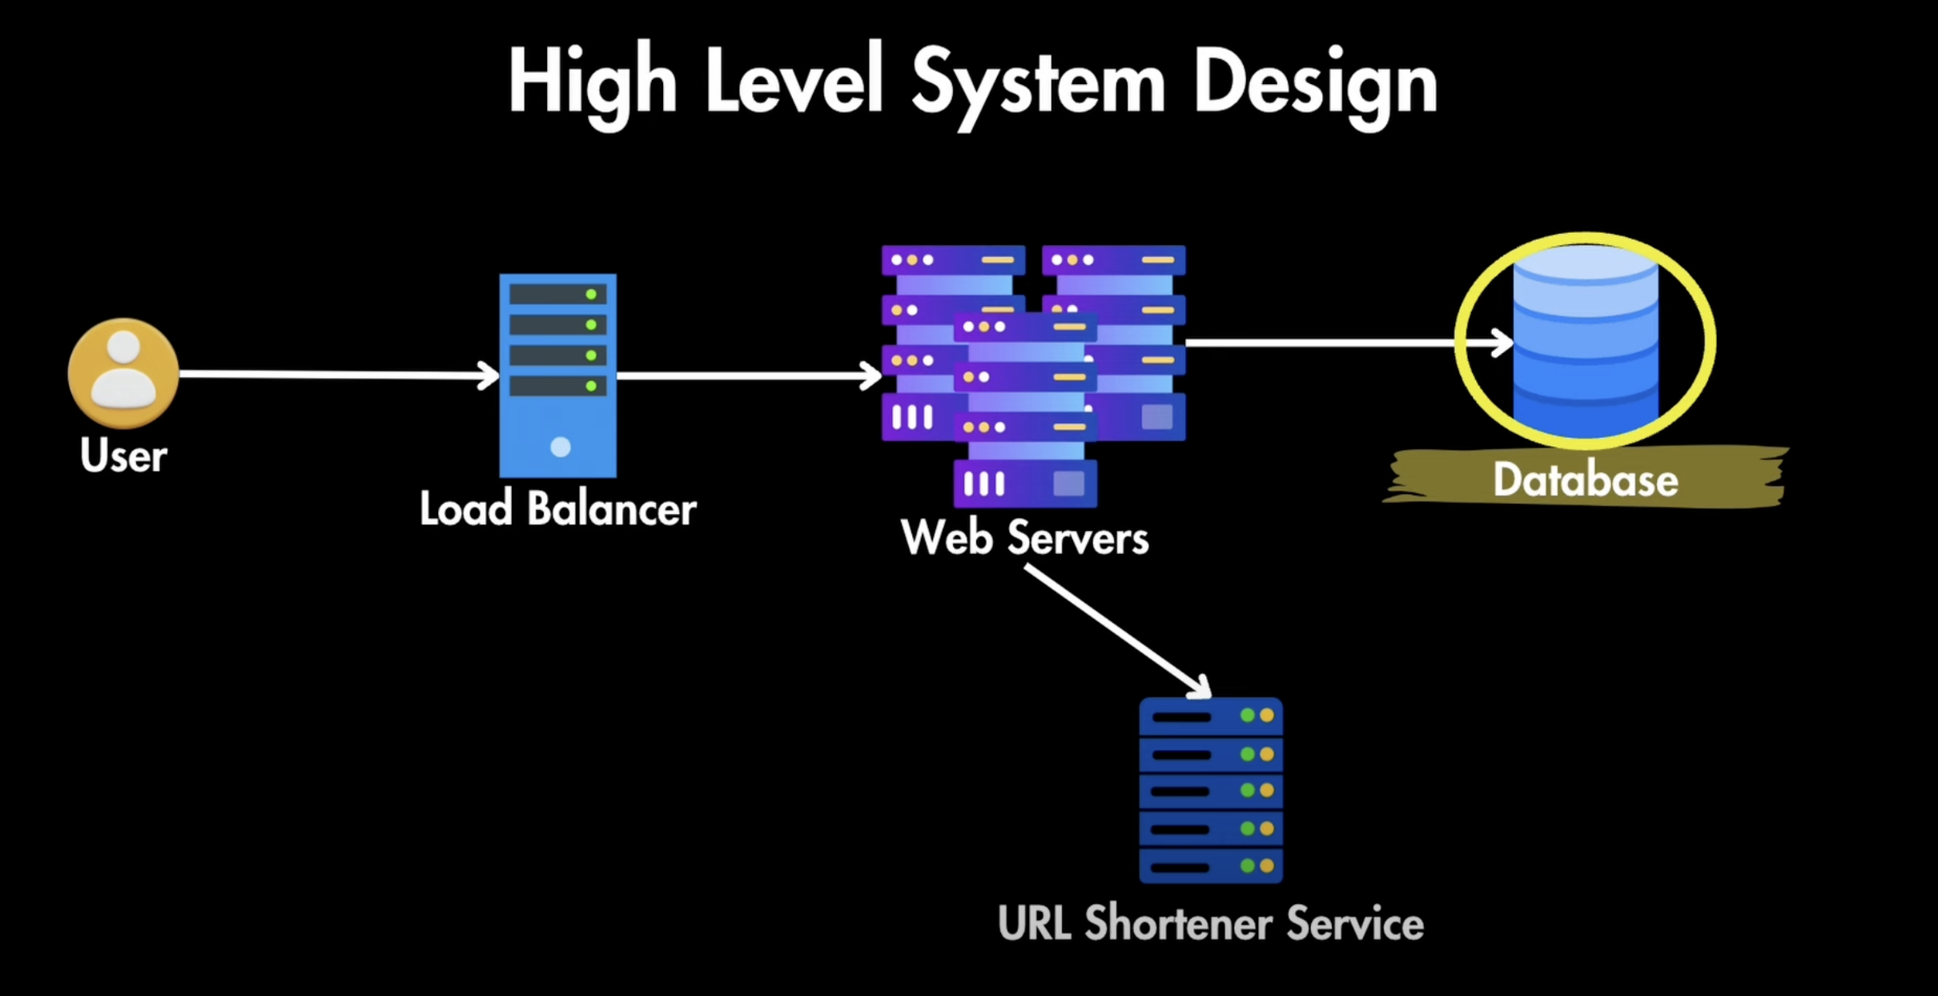

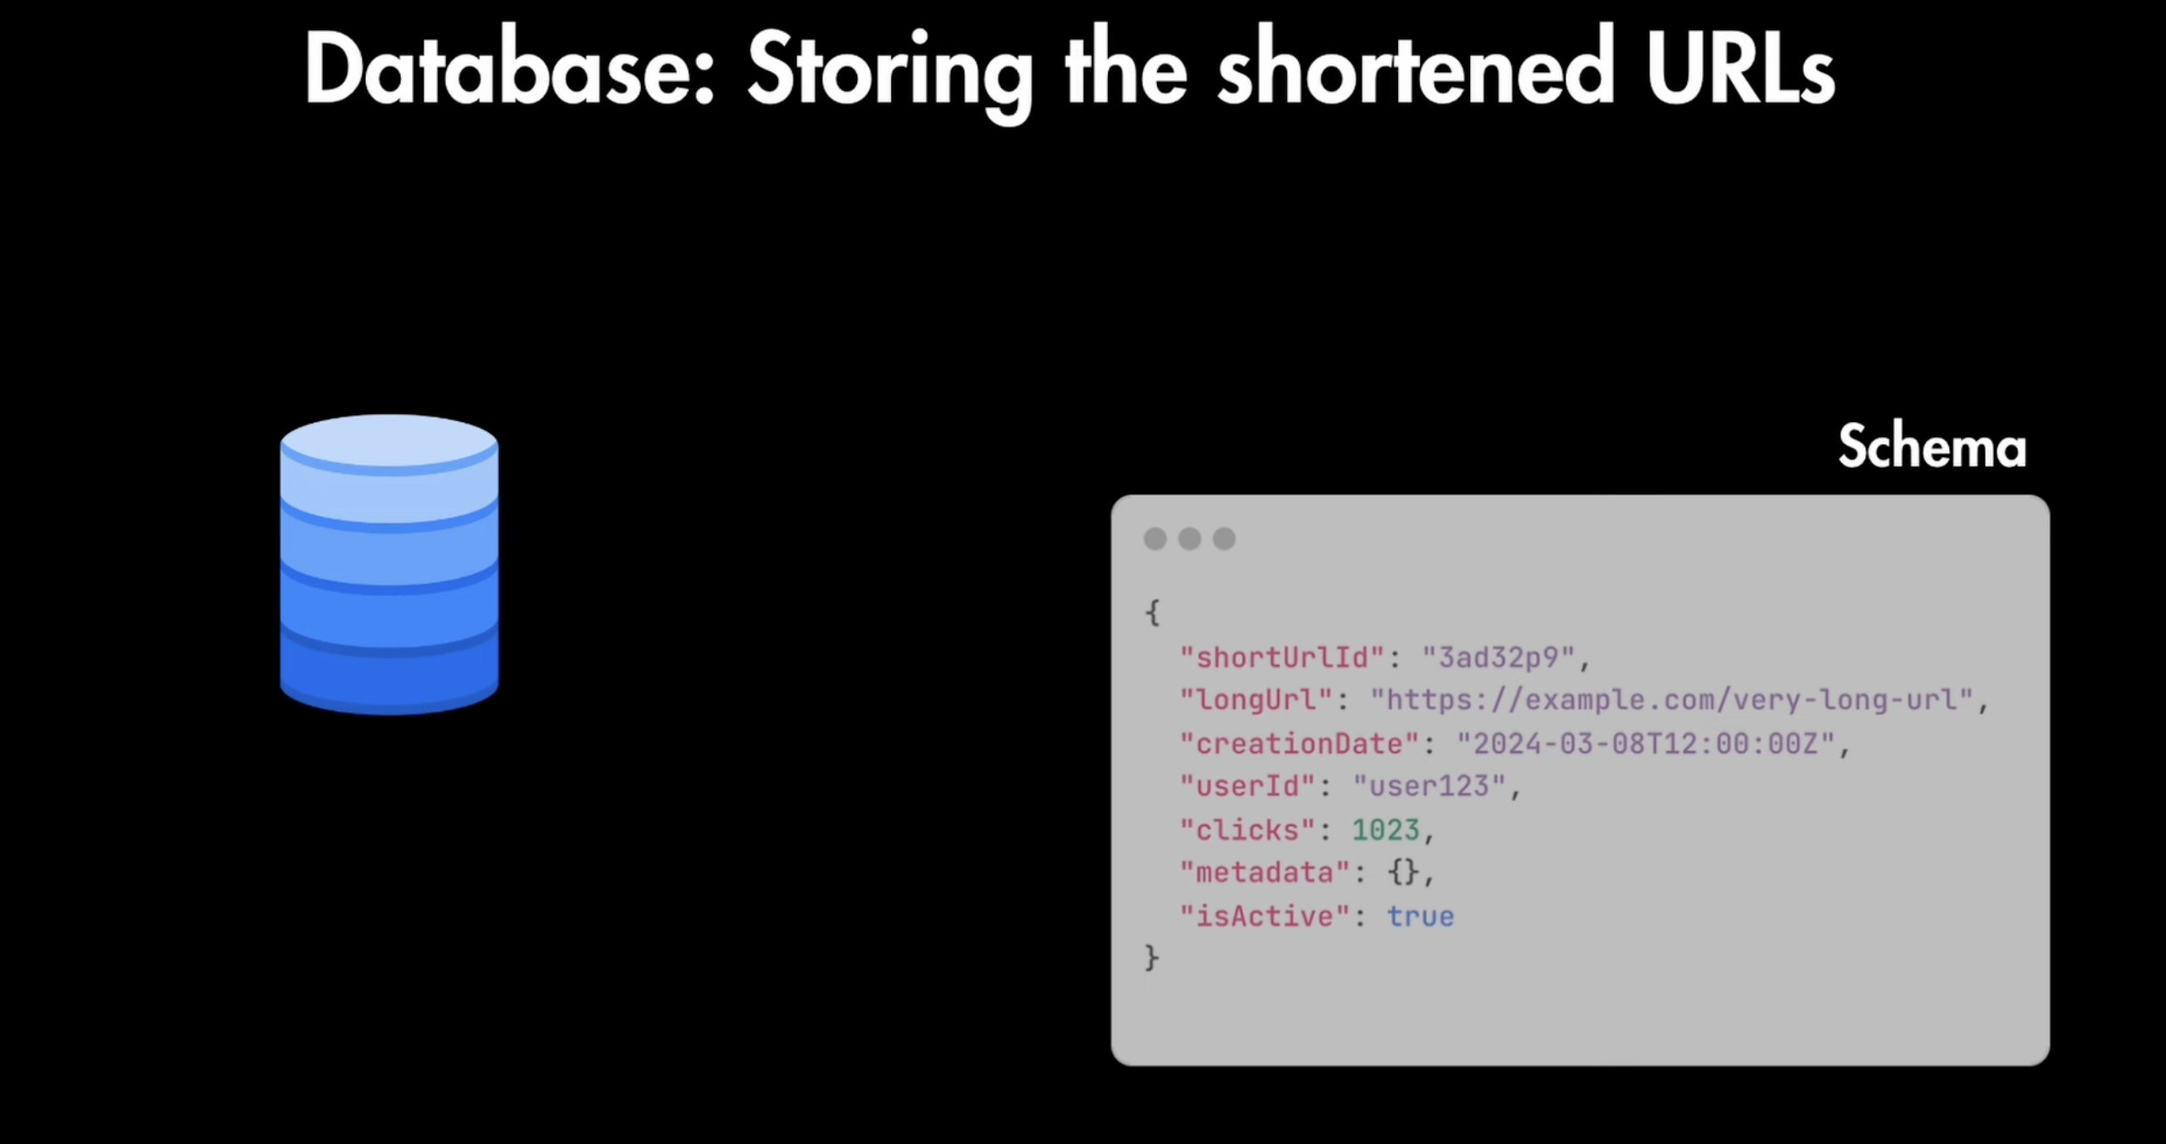

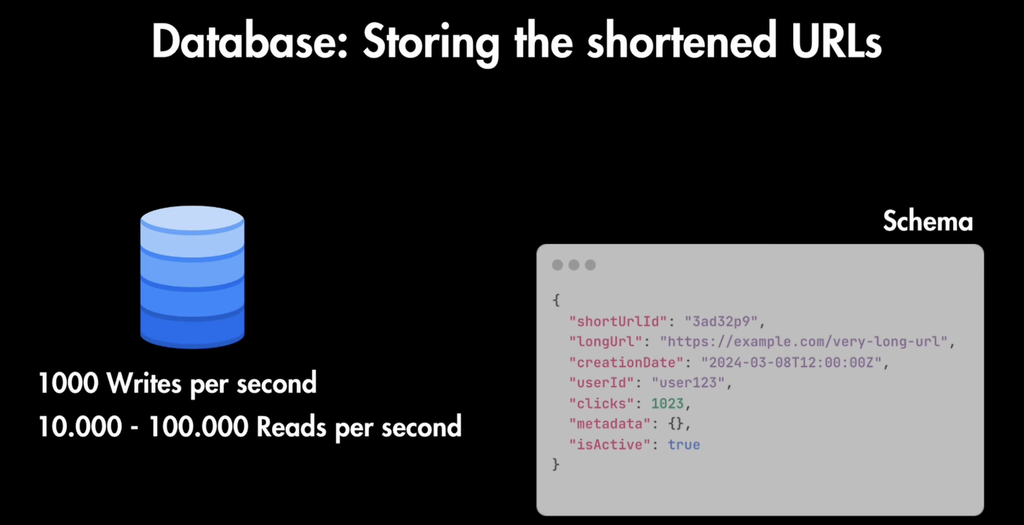

**Since, we have to write 1000 writes per second of 1000000 per send, then we need NOSQL database like MONGO DB**

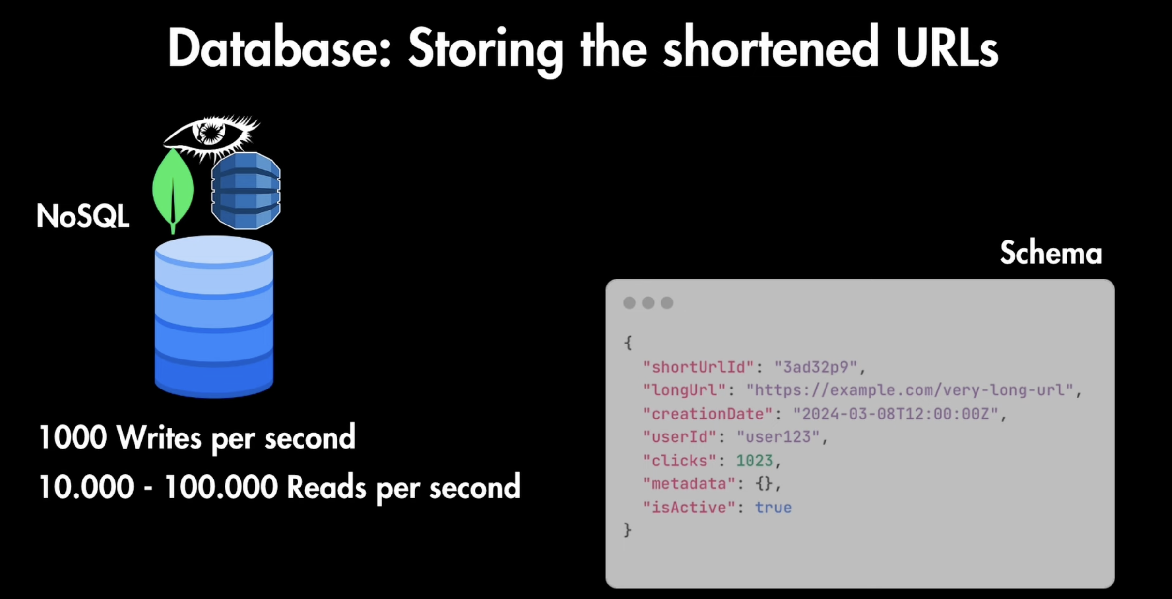

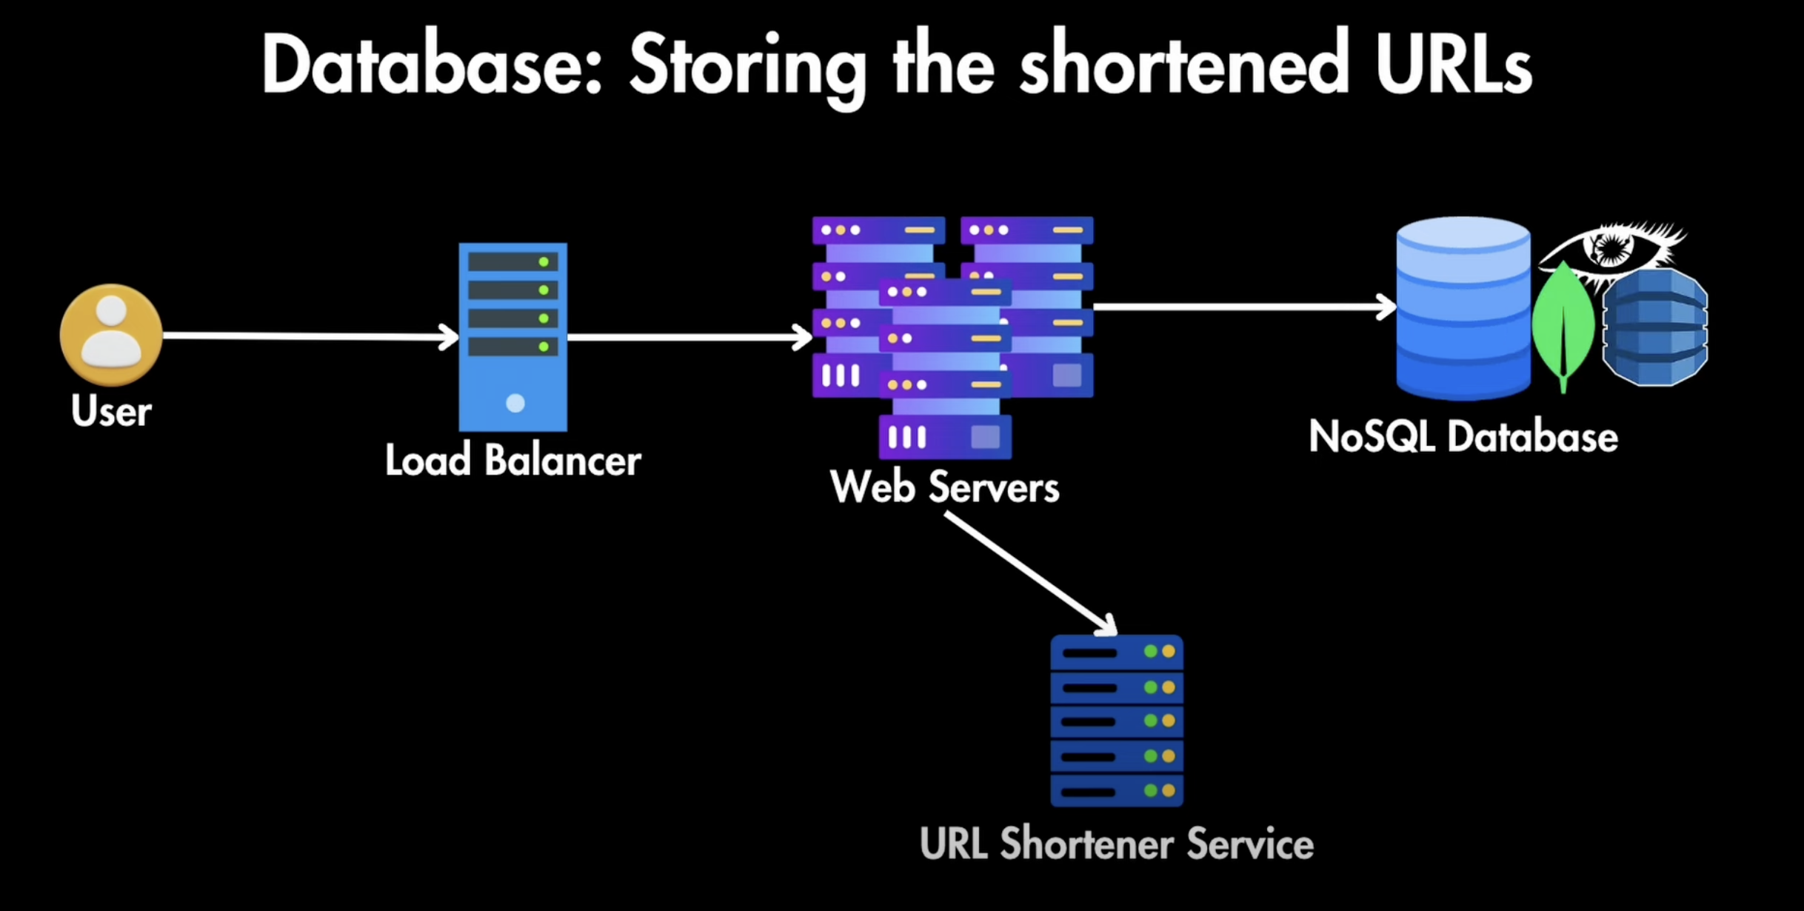

**URL Shortener Service**

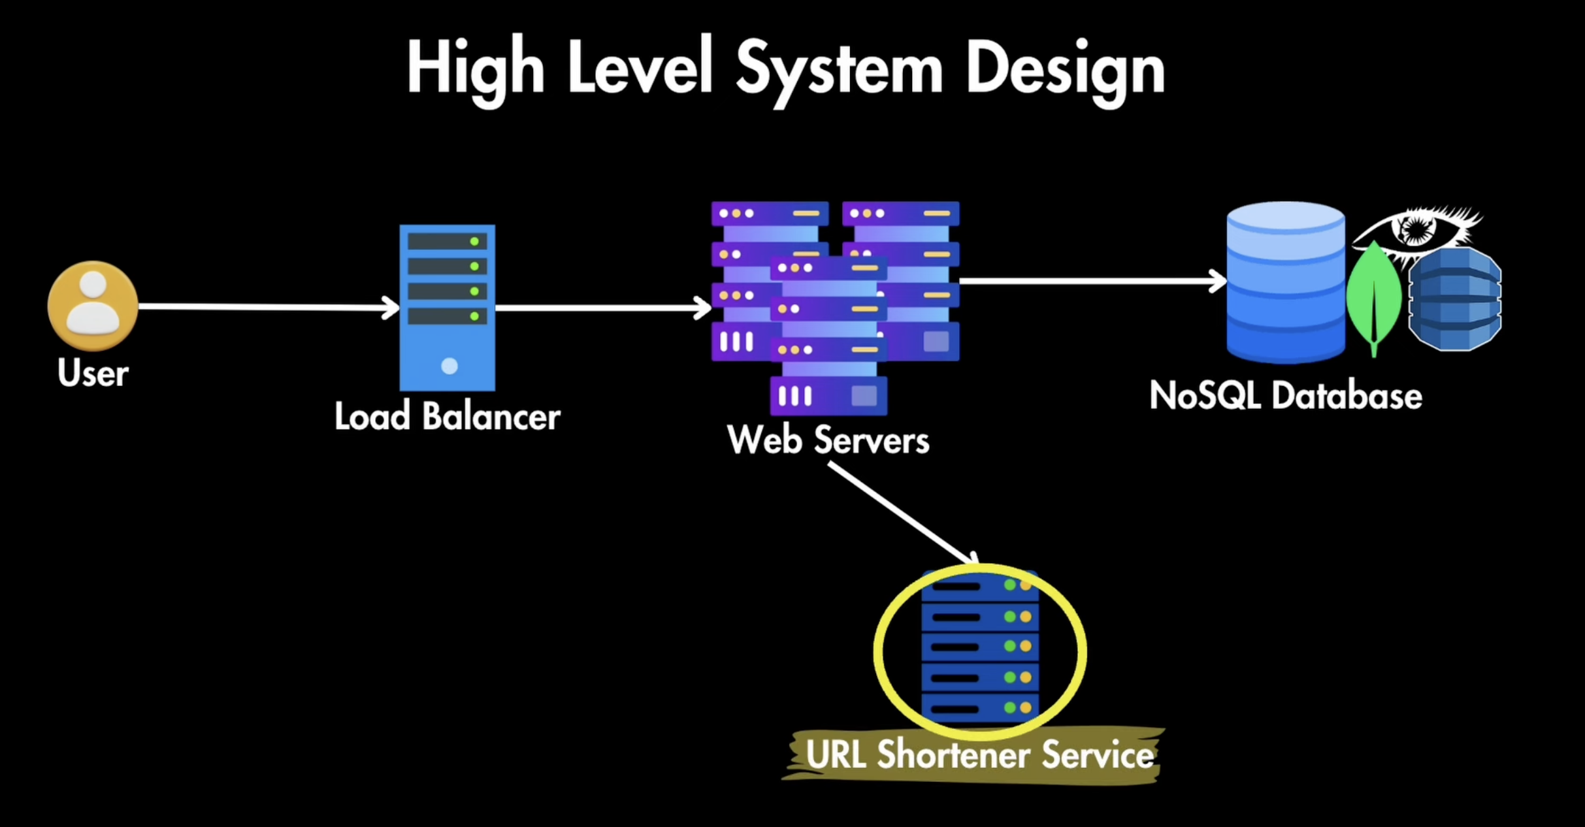

**This service is used to short the Long URl without collision i.e long url should not create same short URL. To avoid this we can use**

1. **Hashing(can lead to collision)—We can use hashing to which will create the hash of long URL.**
2. **Auto increment ID(ensures uniqueness but might be predictable)-> Since, hashing lead to collision so we can use Auto increment ID.**
3. **Custom Algorithm**

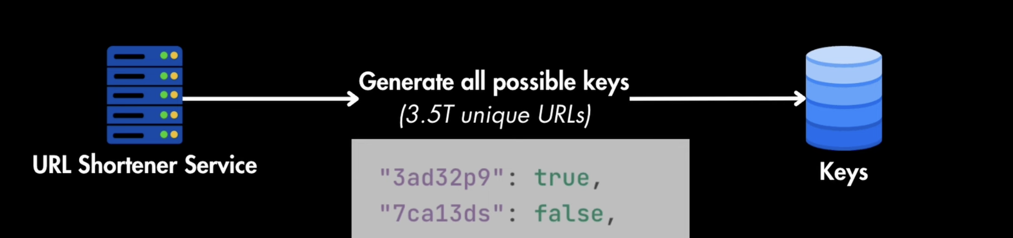

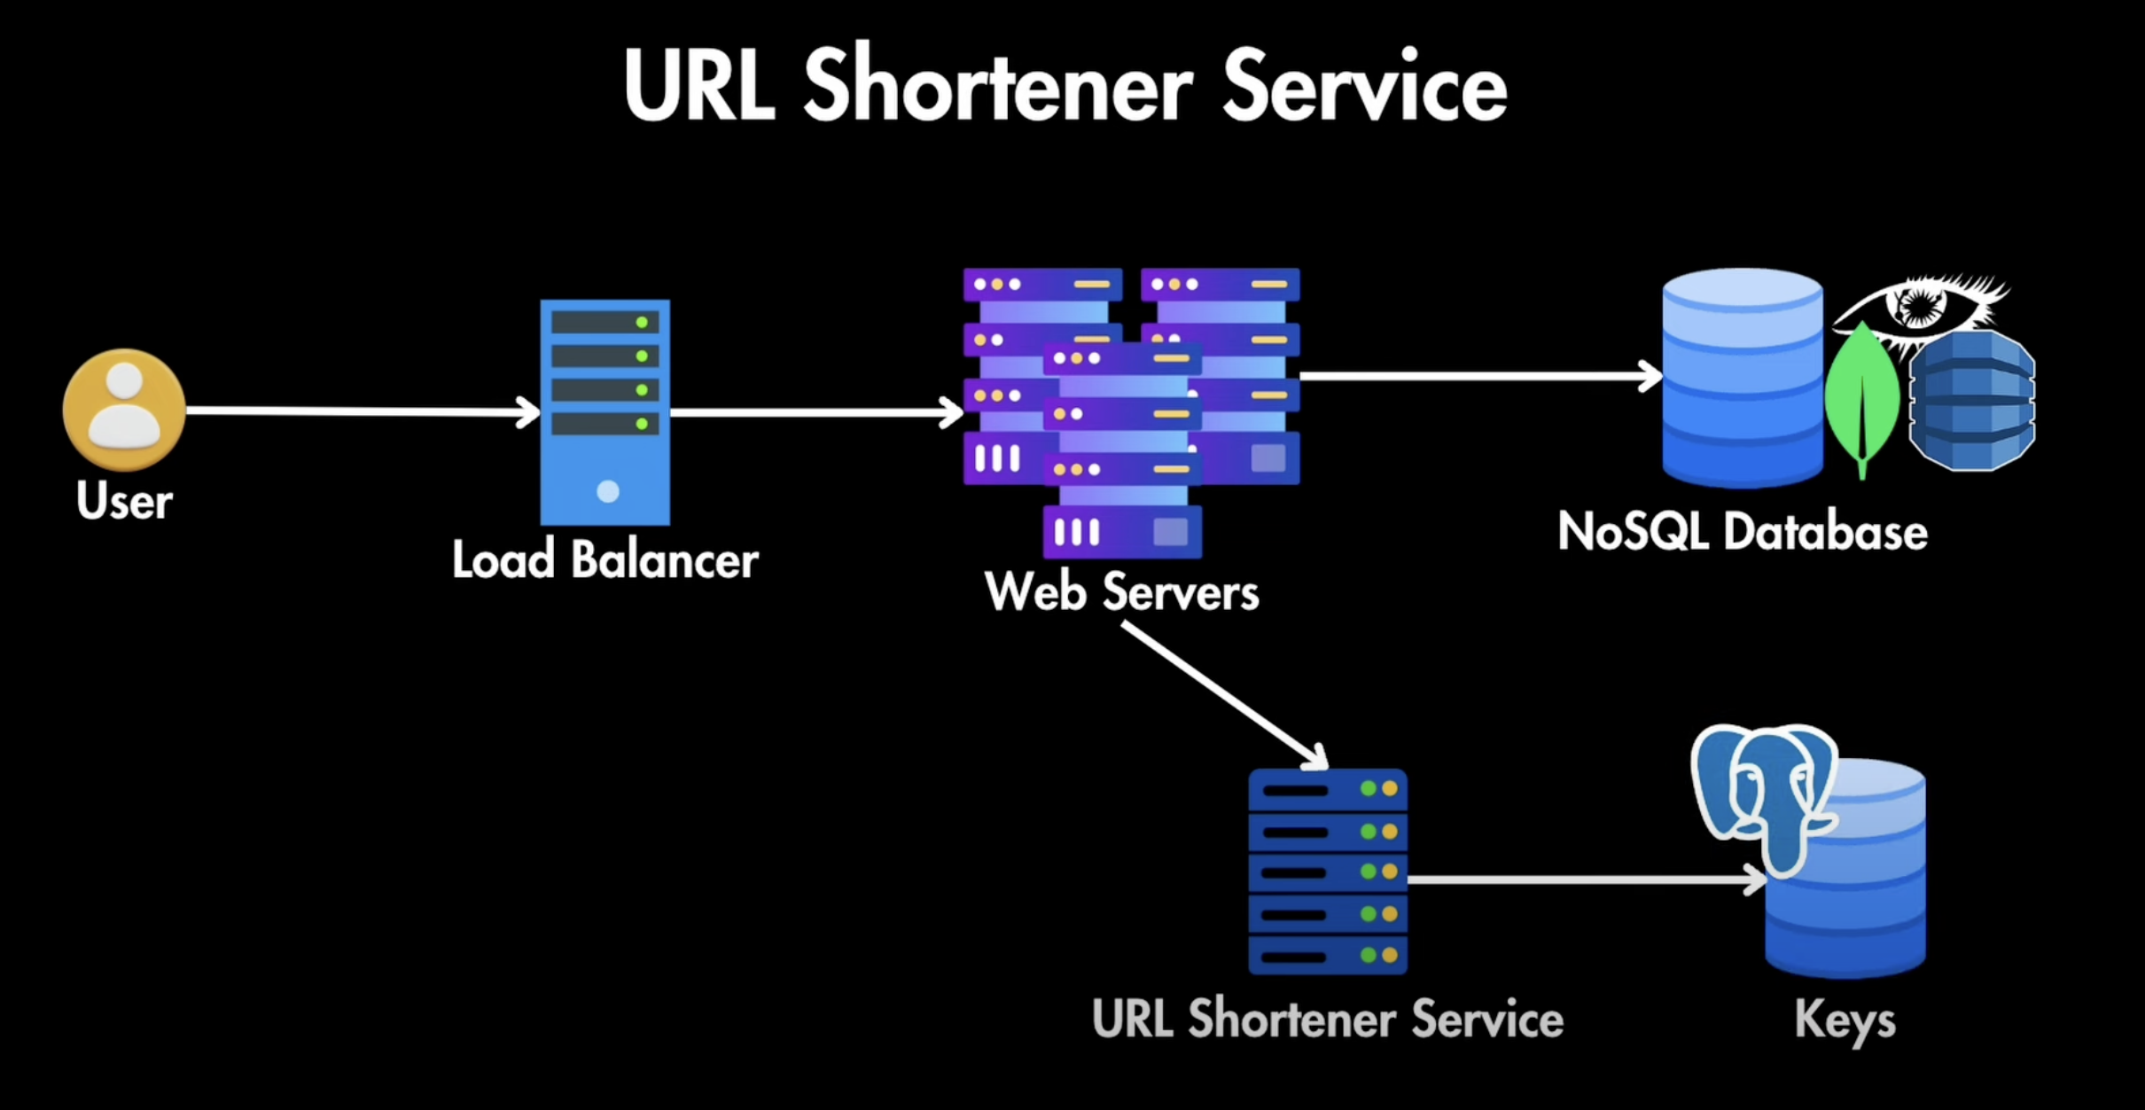

**High Availability and Low Latency**

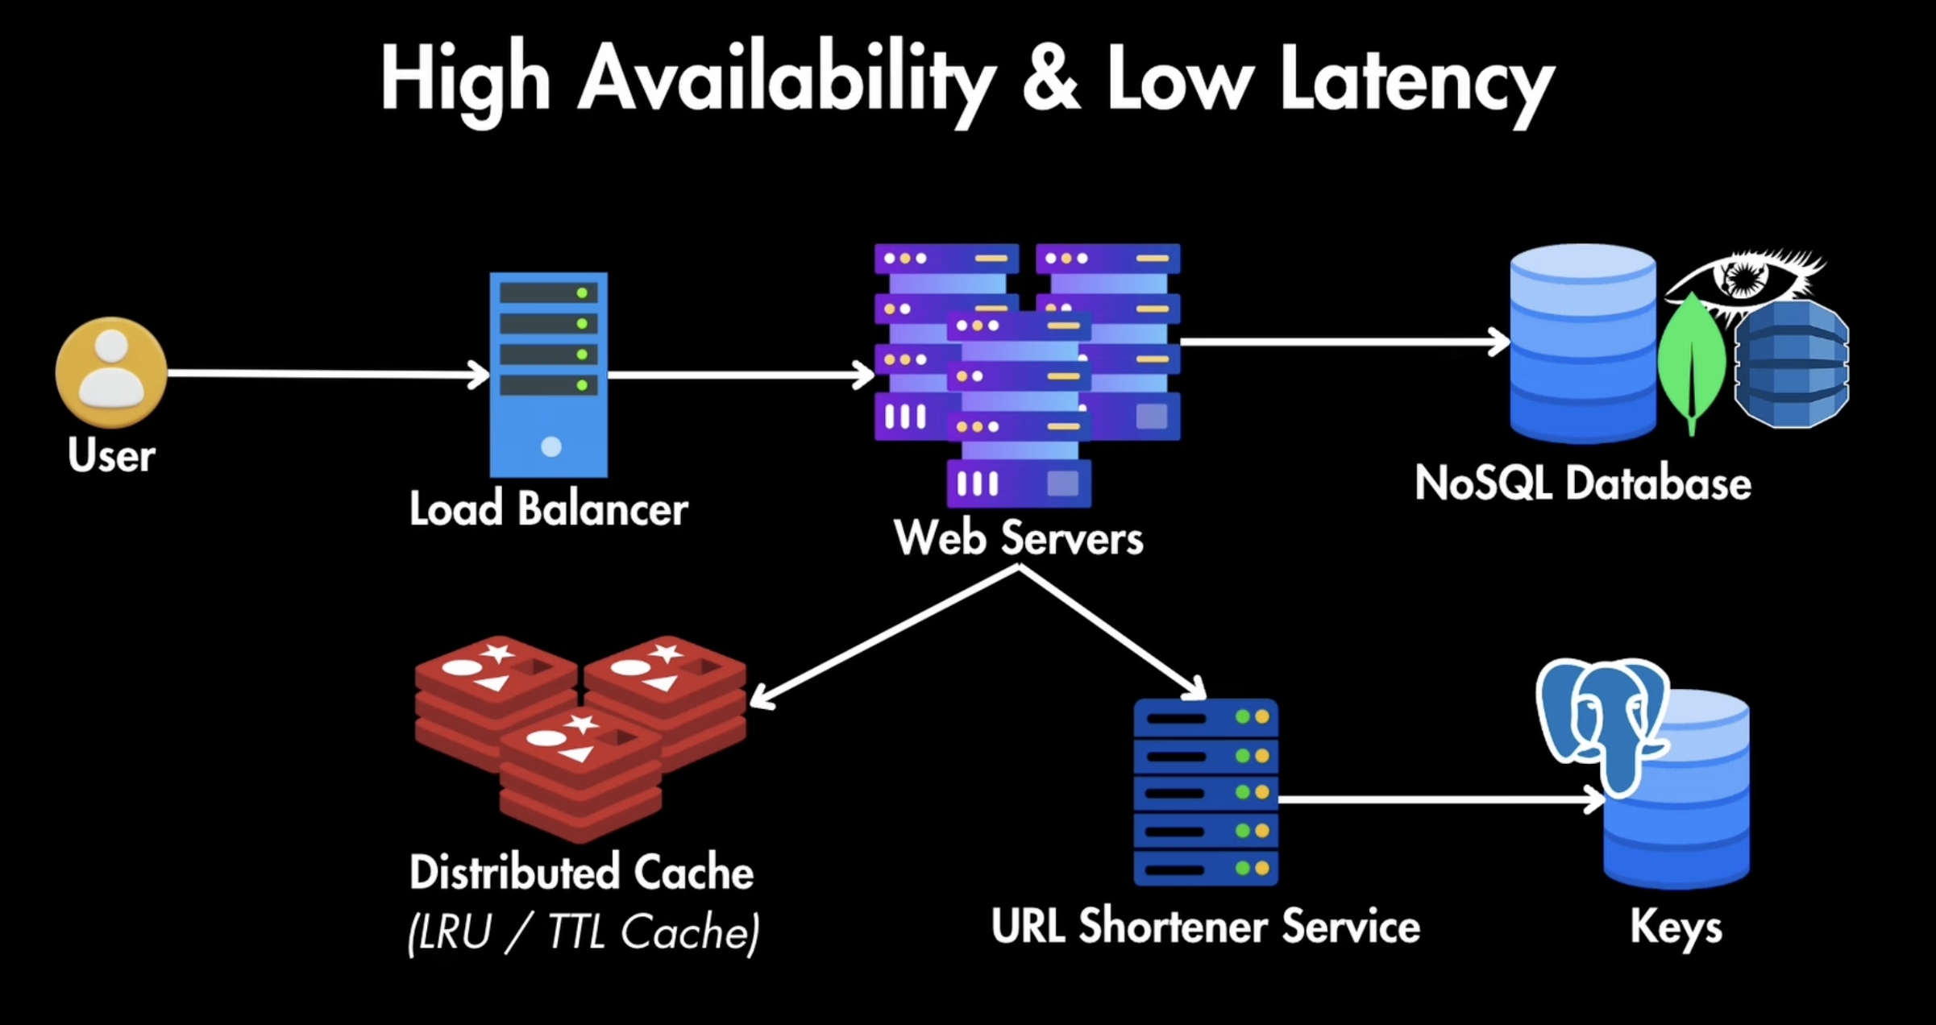

**Database Scaling**

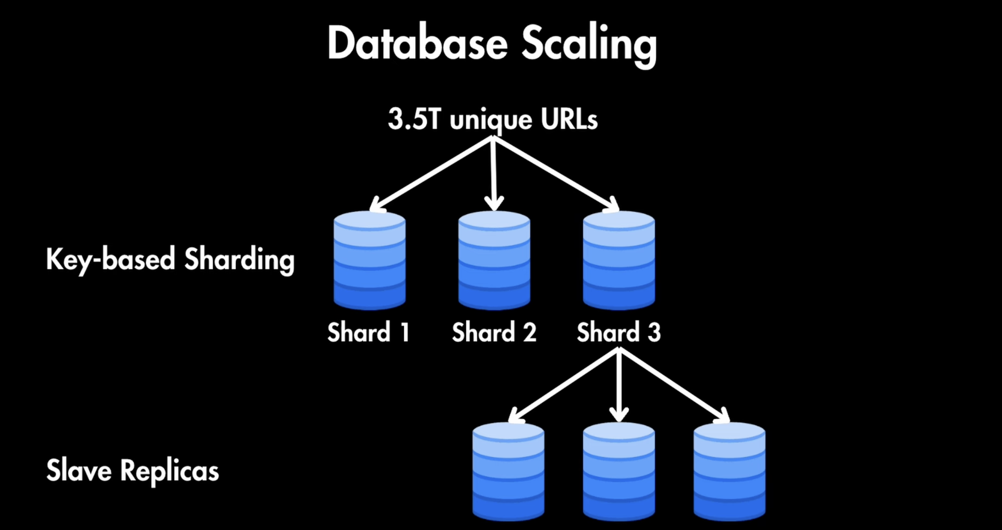

**Let us suppose we have key based sharding and every shard will have 1 trillion data**

**Apart from that, we have master slave sharding also for high availability**

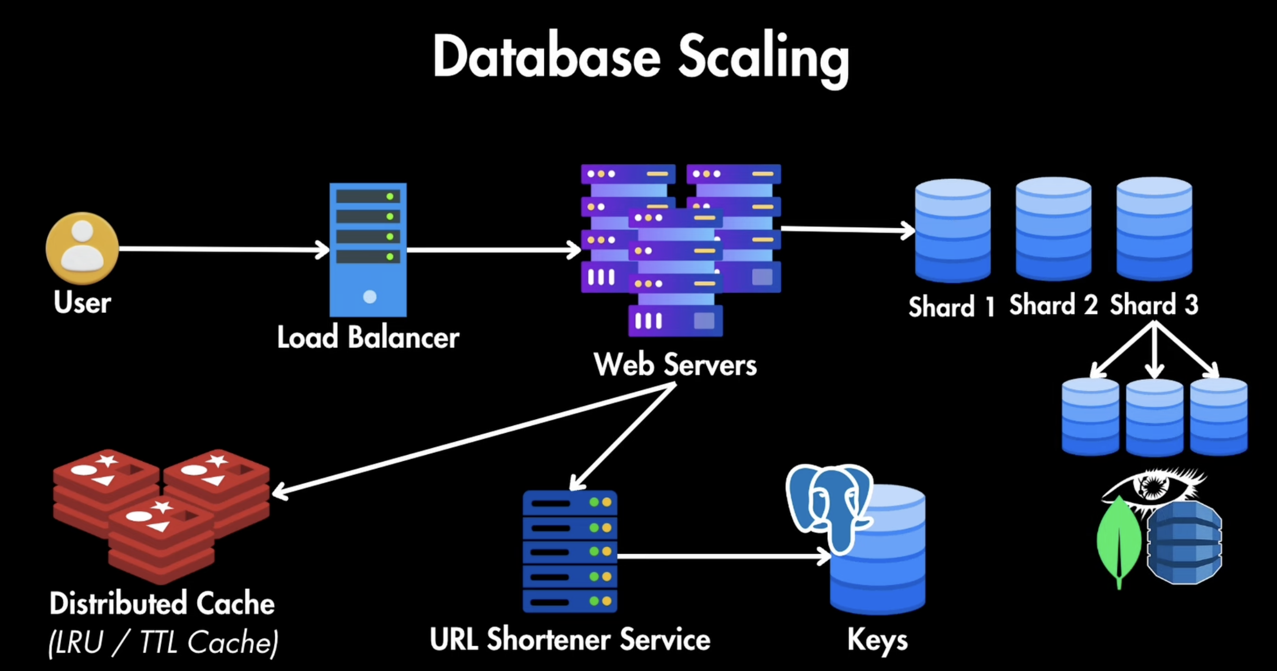

**Security Consideration**

